BDD with Specflow .Net Core
https://www.youtube.com/watch?v=O5oHiBD5Lvk
BDD bridges the gap between QA/BA/Developer/Stake Holder
There are many tools available to support BDD , some most famous tools are
Cucumber
Jbehave – Java / Nbehave - C#
SpecFlow – C #

Gherkin is the format for Cucumber specification
It is a business readable , domain specific language which will let anybody to understand the software behavior easily , since they are plain text

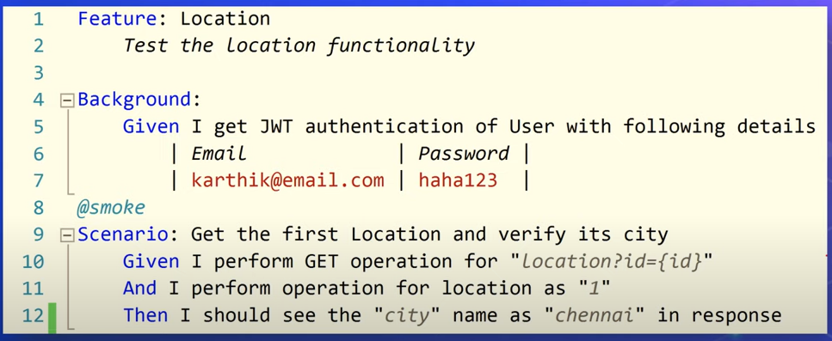

Specflow for VS 2019
NUnit Test Adapter

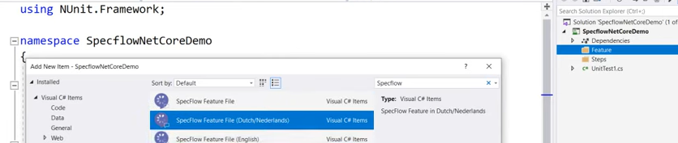

Nuget packages
Specflow
Specflow.NUnit
Specflow.Tools.MsBuild.Generation

Selenium.WebDriver
Selenium.WebDriver.ChromeDriver

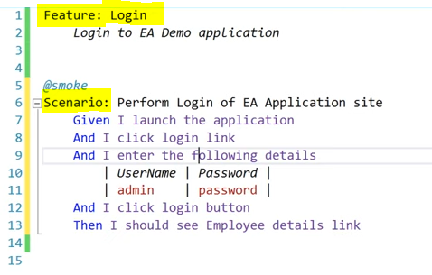
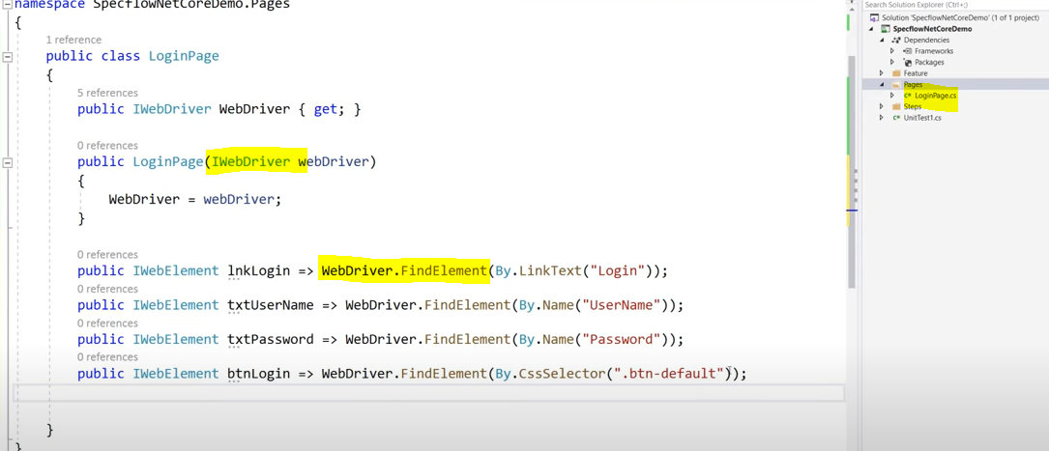

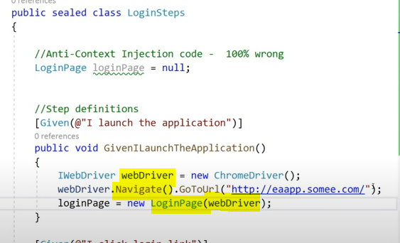

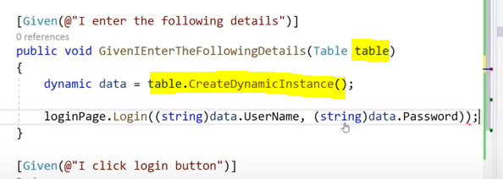
https://www.gokhan-gokalp.com/en/behavior-driven-development-with-dotnet-net-core-and-visual-studio-for-mac/

